**BALLAJURA COMMUNITY COLLEGE**

**Year 12 Applications SAMPLE**

**Test 4 – Time series and Finance**

Calculator Assumed

Name: __________________________Time: 55 min Marks: ______ /5 5

1. [1,1,1,2,2 : 7 marks]  
     
   An annuity compounds interest annually and its value after $n$ withdrawals can be modelled using the recurrence relation

$$T_{n+1}=1.048T_{n}-37 400, T_{0}=475 000.$$

a) Use the relation to state

i) the annual percentage interest rate.

ii) the initial value of the annuity.

b) Calculate the balance of the annuity, to the nearest dollar, after $4$ withdrawals.

c) The annuity is closed after $15$ withdrawals. Calculate the total interest paid by the annuity up to this time.

d) From the outset, the annual withdrawal can be reduced so that the annuity becomes a perpetuity. Briefly explain what a perpetuity is and determine the withdrawal required.

2. [1,2, 3: 6 marks]

The deseasonalised number of working holiday makers in Australia over the four-year period from March 2014 to December 2017 was modelled by $n=160.83-1.431t$, where $n$ is the number of people in thousands and $t$ is the quarter, with $t=1$ corresponding to March 2014.

The Seasonal Index table is shown below.

|  |  |  |  |  |
| --- | --- | --- | --- | --- |
| Quarter | March | June | September | December |
| Seasonal Index | $$1.06$$ | $$x$$ | $$0.95$$ | $$1.03$$ |

a) Determine the value of $x$ in the table above.

b) State, with reasons, whether the number of working holiday makers in Australia was highest during September 2017 or during September 2014.

c) Use your knowledge of time series to estimate the actual change in the number of working holiday makers in Australia from December 2017 ( $t=16)$ to March 2018 (.

3. [3, 2, 2, 3 : 10 marks]

The number of people ($n$, in thousands) studying in Australia with a student visa from $2015$ to $2017$ are shown in the graph and table below.

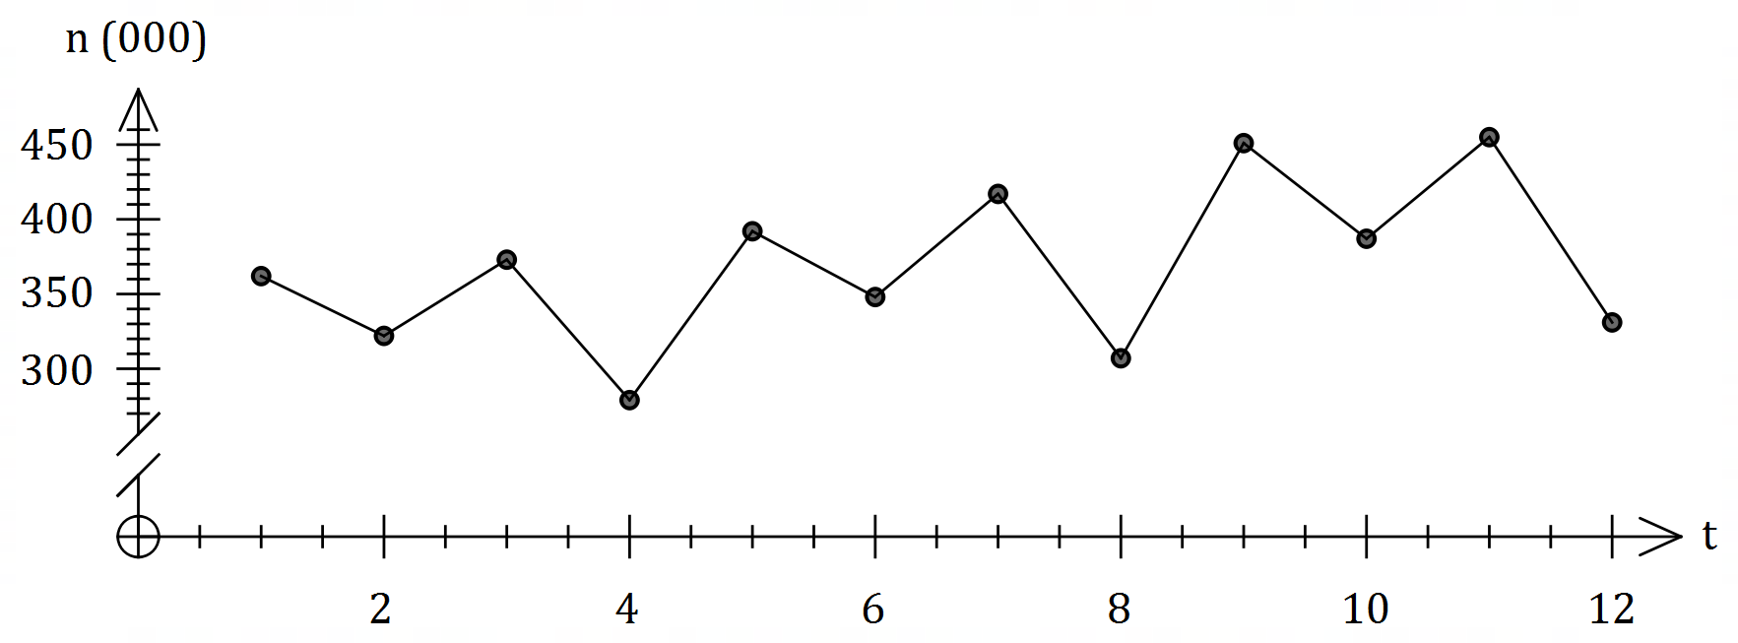

|  |  |  |  |  |  |
| --- | --- | --- | --- | --- | --- |
| Year | Quarter | Time ($t$) | Number ( $n$ $000$'s) | Quarterly mean | Percentage of quarterly mean |
| $$2015$$ | $$1$$ | $$1$$ | $$362$$ | $$334$$ | $$108.4$$ |
| $$2$$ | $$2$$ | $$322$$ | $$96.4$$ |
| $$3$$ | $$3$$ | $$373$$ | $$111.7$$ |
| $$4$$ | $$4$$ | C | $$83.5$$ |
| $$2016$$ | $$1$$ | $$5$$ | $$392$$ | $$366$$ | $$107.1$$ |
| $$2$$ | $$6$$ | $$348$$ | $$B$$ |
| $$3$$ | $$7$$ | $$417$$ | $$113.9$$ |
| $$4$$ | $$8$$ | $$307$$ | $$83.9$$ |
| $$2017$$ | $$1$$ | $$9$$ | $$451$$ | $$A$$ | $$111.1$$ |
| $$2$$ | $$10$$ | $$387$$ | $$95.3$$ |
| $$3$$ | $$11$$ | $$455$$ | $$112.1$$ |
| $$4$$ | $$12$$ | $$331$$ | $$81.5$$ |

a) Determine the value of $A$, the value of $B$ and the value of $C$ in the table above.

b) Complete the missing values in the seasonal index table below.

|  |  |  |  |  |
| --- | --- | --- | --- | --- |
| Quarter | $$1$$ | $$2$$ | $$3$$ | $$4$$ |
| Seasonal Index | $$1.089$$ |  | 1.126 |  |

c) Calculate the deseasonalised number of people studying in Australia with a student visa in the third quarter of $2016$.

Let $N$ represent all the deseasonalised values of $n$. The equation of the least-squares line for $N$ against $t$ is given by $N=7.97t+326.9$.

d) Determine an estimate for the number of people studying in Australia with a student visa in the fourth quarter of $2018$ if the existing trend and seasonality continues.

4. [2, 2, 3 : 7 marks]

A reducing balance loan is defined by the recurrence relation $T_{n+1}=a×T_{n}-b, T_{1}=c$, where $Tn$ is the balance of the loan in dollars at the start of month $n$. The relation was used to create the following spreadsheet.

|  |  |  |  |  |
| --- | --- | --- | --- | --- |
| Month $$n$$ | Balance of loan at start of month $n$ | Monthly interest | Monthly repayment | Loan balance carried forward |
| $$1$$ | $$14 500.00$$ | $$118.9$$ | $$420.00$$ | $$14198.90$$ |
| $$2$$ | $$14198.90$$ | $$116.43$$ | $$420.00$$ | $$13895.33$$ |
| $$3$$ | $$13895.33$$ | $$113.94$$ | $$420.00$$ | $$X$$ |
| $$4$$ |  | $$Y$$ |  | $$Z$$ |

a) Determine the annual percentage interest rate that applies to the loan.

b) State the value of each of the constants $a, b$ and $c$ in the recurrence relation.

c) Determine the value of $X$, the value of $Y$ and the value of $Z$ shown in the spreadsheet.

5. [3, 2, 2 : 7 marks]

On $1$ March $2022$ Sam started a new job with an annual salary of $\$84 000$. At that time, the balance of his superannuation fund from previous jobs was $\$50 920$. Sam's new employer deposits a sum equal to $9.15\%$ of his monthly salary into his fund on the last day of each month.

Interest on the balance of an individual's superannuation fund is added on the last day of each month, just before any deposits are made, and the fund advertises an interest rate of $5.7\%$ per annum.

a) Determine the balance of Sam's superannuation fund on $1$ April $2022$.

b) Write a recursive relation for the balance $T_{n}$ of Sam's superannuation fund $n$ months after she started her new job.

c) Calculate the expected increase in the balance of Sam's superannuation fund after he has been in his new job for one year and if his circumstances do not change.

6. [1, 2, 2, 2, 1, 2 : 10 marks]

A factory operates three consecutive eight-hour shifts A, B and C each day. The table below shows the number of workers who turned up late for each shift, together with a three-point moving average $m$.

|  |  |  |  |  |
| --- | --- | --- | --- | --- |
| Time period $t$ | Day | Shift | Number late | Moving average $m$ |
| $$1$$ | Sun | A | $$47$$ | $$-$$ |
| $$2$$ | Sun | B | $$35$$ | 41 |
| $$3$$ | Sun | C | $$41$$ | $$P$$ |
| $$4$$ | Mon | A | $$44$$ | $$37$$ |
| $$5$$ | Mon | B | $$26$$ | $$36$$ |
| $$6$$ | Mon | C | $$38$$ | $$35$$ |
| $$7$$ | Tue | A | $$41$$ | $$35$$ |
| $$8$$ | Tue | B | $$Q$$ | $$34$$ |
| $$9$$ | Tue | C | $$35$$ | $$-$$ |

a) Briefly describe the purpose of calculating a set of moving averages for a time series.

b) Determine the value of $P$ and the value of $Q$ in the table above.

c) Determine the centred six-point moving average for $t=5$.

d) Determine the least-squares line to predict $m$ from $t$.

Two of the seasonal indices for the above time series are shown in the table below.

|  |  |  |  |
| --- | --- | --- | --- |
| Shift | A | B | C |
| Seasonal index | $$1.19$$ |  | 1.03 |

e) Calculate the seasonal index for shift B.

f) Forecast the number of late workers for the next C shift (on Thursday), using the  
least-squares line from (d) and making any necessary seasonal adjustment.

7. [2, 3, 2 : 7 marks]

A person has a credit card account with an outstanding debt of $\$2 793$ and the card provider charges interest at a rate of $14.45\%$ per annum compounded daily.

a) Determine their card debt in $30$ days' time if the card is not used for any more purchases and no repayments are made.

The person can pay off their card debt using an unsecured loan from their bank at an interest rate of $14.5\%$ compounded monthly.

b) Use effective interest rates to determine, with reasoning, whether the unsecured loan would be a better option for this person.

The person chose to pay off their card debt in full by taking out a two year secured loan for $\$2 793$ from a lender who compounds interest quarterly. At the end of this time, the person must repay the principal and interest, a sum of $\$3 390.84$.

c) Determine the interest rate charged by this lender.